Annecy Listening

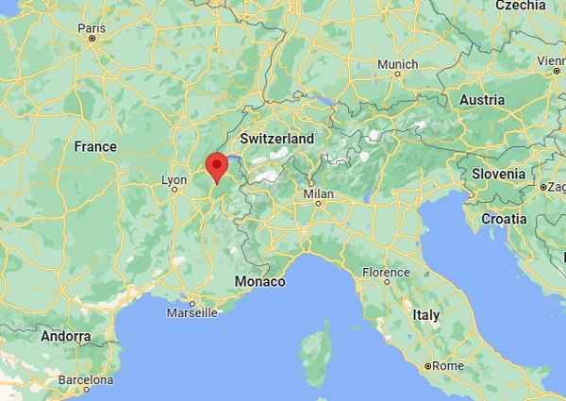

- How many people live in Annecy and the surrounding villages?

a. 50, 000 b. 75, 000 c. 100,000 d.200, 000
2. How is this town described? Write down one adjective. _______________________________
3. Which festival attracts thousands of tourists? _________________________________________
4. What does the festival each year. Check all that apply.
a. a parade b. fireworks c. dances d. water sports
e. a theme f. BBQ g. bands h. a boat show
5. At what time of day does the festival of old Annecy take place ?_________________________
6. In which months does the transhumance take place?
_____________________________________________________________________________
7. What is it?
a. bringing animals down from the mountains b. celebrating the local saints’ lives
c. bringing the harvest in d. taking animals to market
8. Name one way in which they celebrate at this festival. ________________________________
9. What two geographical attractions are mentioned that attract tourists who want to enjoy sports?
_____________________________________ _____________________________________

